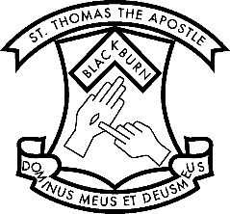
Prep Enrolment and Transition Timeline (2020 to 2021)
Current School Year

FEBRUARY Enrolments Open.

FEBRUARY-MARCH School Tours and Open Sessions
(Open Sessions – Monday 16 March 9.00am – 10.00am, Thursday 19 March 11.45am – 12.45pm and Wednesday 15 April 9.00am-10.00am.

EARLY-MID MAY Enrolment Interviews for all those who have applied with the Principal.

MID MAY The Principal and Parish Priest decide on acceptances according to the criteria in the Enrolment Policy and the number of places available.

LATE MAY (31ST) Letters sent to families advising of an offer of a place for their child, or of a place on the Waiting List.

BY MID JUNE Parents must reply with an Acceptance Form and a $100 payment to secure their place.

TERM THREE ‘Come and Visit‘ – once accepted, your child will be invited to some sessions at the school across Term Three. These are optional.
- Story Time in the Library
- A PE session
- A visit to the garden Dates and times to be advised.

EARLY TERM FOUR Parents advised of our staff visiting Kinders and Child Care Centres.

NOVEMBER Parent Information Night.

LATE NOVEMBER Child attends two Orientation Sessions for
(Two dates offered) 1.5 hours. The children will be in the classrooms with the Prep teachers for 2021.

BEFORE SCHOOL CLOSES Letters sent to parents advising of the teachers in Prep and in which class their child has been placed. The Countdown Calendar is included with this.

JANUARY The Prep teachers send a Welcome Letter
(Before school starts) to their new class.

